**SQL LAB ASSIGNMENT-2**

NAME:AGILAMBAL S

REG NO:731621121003

EMAIL:agilambal5s@gmail.com

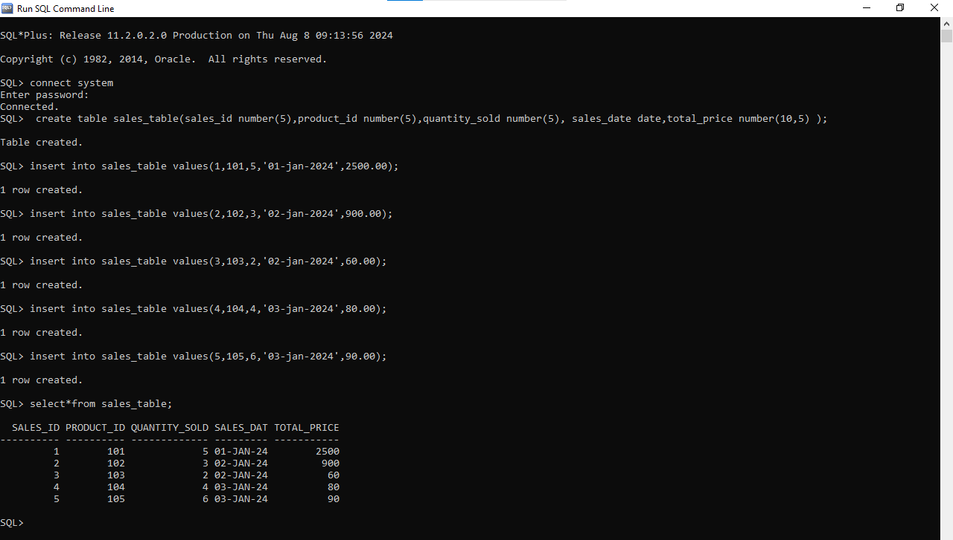**1.Create the following Sales table.**

**2. Retrieve all columns from the Sales table.**

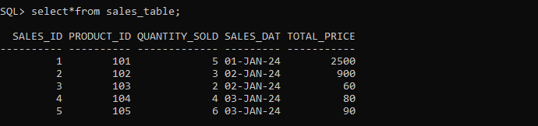

**3.Retrieve sale_id and quantity_sold from sales table.**

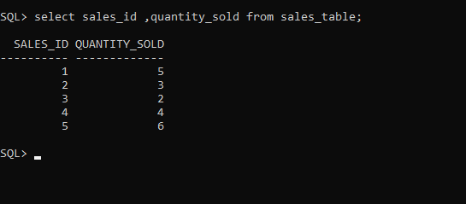

### 4. . Filter the Sales table to show only sales with a total_price greater than $100.

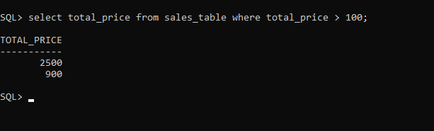

### 5. Retrieve the sale_id and total_price from the Sales table for sales made on January 3, 2024.

### 

### 6. Retrieve the sale_id, product_id, and total_price from the Sales table for sales with a quantity_sold greater than 4.

### 

### 7. Retrieve all columns from the Sales table those sale_id are 1, 3 & 5.

### 

**8. Retrieve all columns from the Sales table those total_price between 90 and 1000.**

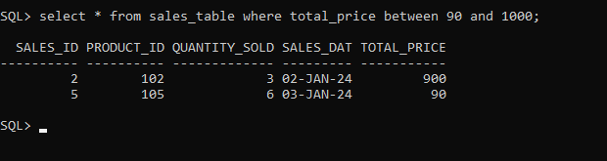

**9. Retrieve all columns from the Sales table those total_price not between 90 and 1000.**

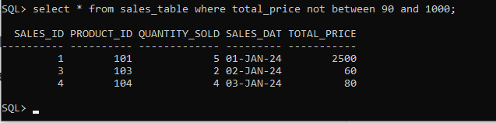

**10. Retrieve all columns from the Sales table those sale_id are not in 1, 3 & 5.**

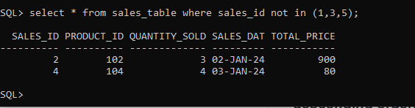

**11. Update total_price as 500 in the Sales table those sale_id are 1, 3 & 5.**

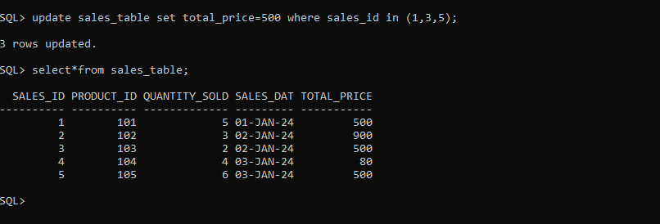

**12. Delete from the Sales table those total_price not between 90 and 1000.**

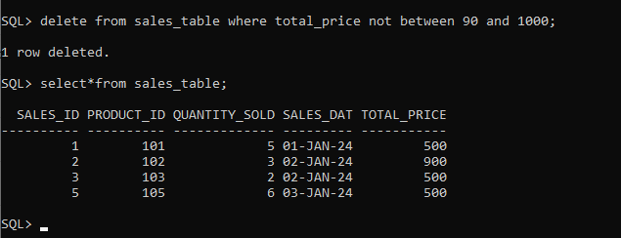

**13. Sort all the records using sale_id column in ascending order**

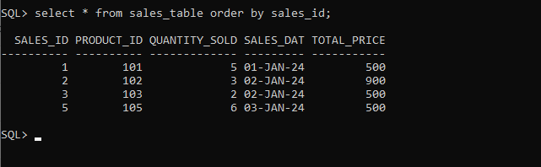

**14. Sort all the records using sale_id column**

**indescendingorder.**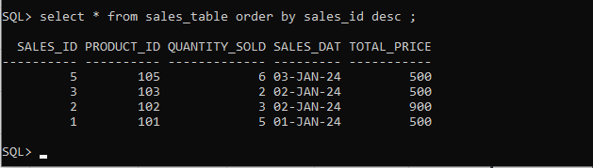

**15. Rename the sale_id column as sales_id;**

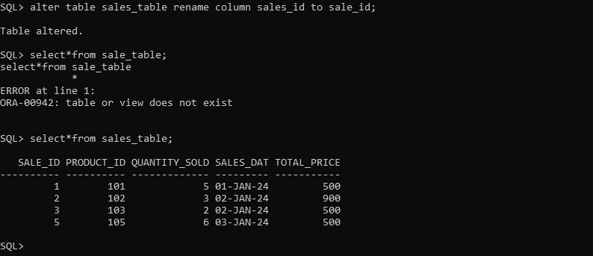

**16. Drop the column sales_id.**

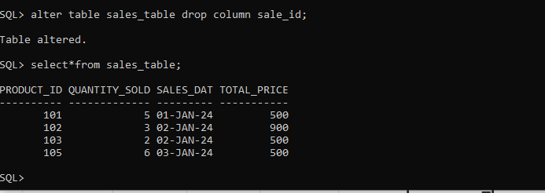

**17. Rename the table as tbl_sales.**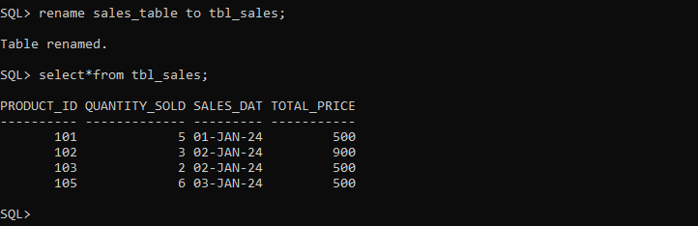

**18. Drop the table.**

